**PERSONAL PROFILE**

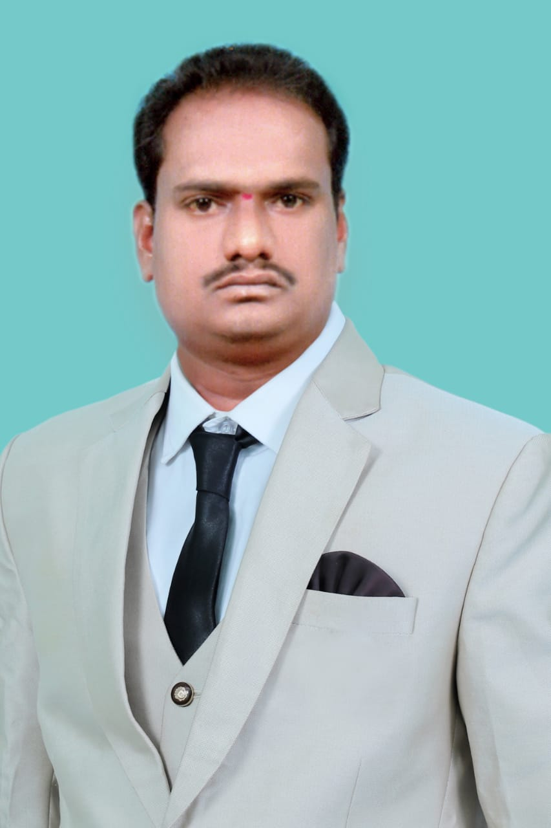

**K.RAGHAVENDRA , M.S,C., B.Ed.**

**Lecturer in CHEMIESTRY**

**S.K.P Government College,**

**Guntakal, Anantapur District, Andhra Pradesh,**

**Mobile: 9398262994**

**Email:kilariraghavendra700@gmail.com**

*_________________________________________________________________________________*

1. **Academic Qualifications and Other details:**

Subject : CHEMISTRY

Highest Educational Qualification : M.S.C

Aadhar No :851570510629

PAN No : BOYPR4912R

Employee ID ( for regular staff only ) : CONTRACT

Date of Birth :15/04/1985

Social Category : BC(D)

Caste : GOLLA

Religion : HINDU

Gender : MALE

1. **Date of Joining service as**
2. Lecturer in Degree College : KURNOOL FOR MEN DEGREE COLLEGE:01/09/2012
3. In S.K.P. College, Guntakal : 24/6/2017

**3. Educational Details:**

|  |  |  |  |  |  |  |
| --- | --- | --- | --- | --- | --- | --- |
| S.No | Class | Institution Name and Place | From | To | % of marks Division | Board/  University |
| 1 | 5 | KV.Z.P.H HIGH SCHOLL VAJRAKARUR | 1994 | 1995 | -- |  |
| 2 | 6 | “ | 1995 | 1996 | -- |  |
| 3 | 7 | “ | 1996 | 1997 | -- |  |
| 4 | 8 | “ | 1997 | 1998 | -- |  |
| 5 | 9 | ” | 1998 | 1999 | -- |  |
| 6 | SSC | “ | 1999 | 2000 | 55% | S.S.C BOARD |
| 7 | Inter I year | S.K.P JUNIOR COLLEGE | 2000 | 2001 | 55% | BOARD OF INTERMIDATE |
| 8 | II year | “ | 2001 | 2002 | “ |
| 9 | UG I Year | S.K.P GOVERNMENT DEGREE COLLEGE | 2005 | 2006 | 58% | SKU |
| 10 | II Year | “ | 2006 | 2007 |  |
| 11 | III Year | “ | 2007 | 2008 |  |
| 12 | PG Iyear | ADONI ARTS& SCIENCE COLLEGE | 2009 | 2010 | 60% | SKU |
| 13 | II Year | “ | 2010 | 2011 |  |
|  | Any other educational |  |  |  |  |  |

1. **Previous Professional (Teaching) Experience :**

|  |  |  |  |  |  |
| --- | --- | --- | --- | --- | --- |
| **S.No** | **Institution** | **From** | **To** | **Designation** | **No.of Years** |
| 1 | KURNOOL FOR MEN DEGREE COLLEGE | 1/09/2012 | 31/03/2013 | LECTURER | 1 |
| 2 | SML GOVERNMENT DEGREE COLLEGE | 6/06/2013 | 31/03/2017 | LECTURER | 4 |
| 3 | S.K.P GDC GUNTKAL | 24/06/2017 | TILL DATE | LECTURER |  |
|  |  |  |  |  |  |
|  |  |  |  |  |  |
|  |  |  |  |  |  |
|  | Add columns if necessary |  |  |  |  |

**pers and Sections handled ( 2017-18)**

|  |  |  |  |
| --- | --- | --- | --- |
| **S.No** | **Course** | **Medium** | **Title of the Paper** |
| **1** | **B.S.C** | **TELUGU** | **INORGANIC &ORGANIC** |
| **2** | **B.S.C** | **TELUGU** | **PHYSICAL CHEMISTRY&GENRAL CHEMISTRY** |
| **3** | **B.S.C** | **TELUGU** | **ENIVERANMENTAL CHEMISTRY** |
|  |  |  |  |
|  |  |  |  |

**International/National attended by the Faculty from 2015-16 to 2019-20**

|  |  |  |  |  |  |
| --- | --- | --- | --- | --- | --- |
| **S.N** | **Name of the Faculty** | **National/ International** | **Institution/place** | **Date** | **Title of the paper Presented** |
| 1 | K.Raghavendra | National Seminar | Govt.Degree college,Uravakonda | 1-03-2018 | Emerging trends in harnessing green energy |
| 2 | K.Raghavendra | National Seminar | Osmania College, Kurnool | 07-02-2015 | Environmental production a global challenge |
| 3 | K.Raghavendra | National Seminar | SML Govt.Degree college,Yemmiganur | 27-02-2017 | Global warming and its impact |
| 4 | K.Raghavendra | National Seminar | Silver Jublee Govt. College, Kurnool | 11-12-2015 | Swachh Bharat-Role of society |
| 5 | K.Raghavendra | National seminar | Govt. College for Men, Kurnool | 27-02-2015 | New Trends on Advanced Material |
| 6 | K.Raghavendra | National seminar | KVR Govt.Degree College, Kurnool | 29-01-2015 | Green Chemistry |
| 7 | K.Raghavendra | National seminar | SML Govt.Degree college,Yemmiganur | 05-10-2016 | Spiritual Education |
| 8 | K.Raghavendra | National seminar | Govt. College for Men, Kurnool | 12-12-2014 | Natural products and Biodiversity |
| 9 | K.Raghavendra | National seminar | Govt.college, Anantapuramu | 07-02-2020 | Emerging trends in chemical environmental science |